Revisions
Revision | Changes | Date
Ed. 1 Rev. 1 | Improved accreditation logo authorization | 09.06.2026
Ed. 1 Rev. 0 | No monitoring for technical experts | 11.03.2024
5 | Section 6: Mark’s dimension update | 13.12.2023
4 | Changes following Assessment Findings from IAS (1st Surv in 1st AC) | 05.07.2023
3 | Added logo for ISO 27001’s accreditation | 12.12.2022
2 | Added logo for ISO 37001’s accreditation | 11.07.2022
1 | Procedure review | 05.04.2022
0 | First issue | 20.07.2021

SCOPE OF APPLICATION
The Client must follow all instructions given by EUROCERTIFICATIONS SRL regarding certification marks rules and certificate usage.
The Clients may use the certification marks in connection with their name or their own trademarks / logo only in accordance with these rules.

TERMS AND DEFINITIONS
• Certificate: the document issued by the Certification Body determining the standard of management system and scope of certification;
• Client: the organization to which the certificate of management system was issued;
• Certification Body: is an organization that certifies the compliance of management systems or personnel with specific reference standards;
• Standards: the standards specified in the certificate of management system issued;
• Use: legal, authorized, limited, non-exclusive and revocable right or license to use the symbols

The other terms and definitions used in the procedure are according to:
• ISO/IEC 17021-1:2015;
• "IAS Policy on IAF/IAS and ILAC/IAS Combined Marks" IAS/ADM/084.

INTRODUCTION
The Certification Body provides the certificate after successfully audit of management systems according to:
- ISO 9001
- ISO 14001
- ISO 45001
- ISO 37001
- ISO/IEC 27001.

The certificates and the certificate mark issued are exclusively property of Certification Body
EUROCERTIFICATIONS SRL.

The IAF/IAS Combined Marks must be placed on the certificates according to "IAS Policy on
IAF/IAS and ILAC/IAS Combined Marks" IAS/ADM/084.

The IAF/IAS Combined MLA Mark can only be used in the following IAF Endorsed Documents:
- ISO 22000 (FSMS)
- ISO 9001 (QMS)
- ISO 14001 (EMS)
- ISO/IEC 27001 (ISMS)
- ISO 13485 (MDMS)
- ISO 50001 (EnMS)
- ISO 45001 (OH&SMS)

GENERAL RULES FOR THE USE OF THE CERTIFICATION MARKS
The certification marks are a graphic symbol used by the Client company for commercial / technical usage:
- The certification mark cannot be changed in shape and content;
- The certification mark cannot be assigned to other users, suppliers or other third parties who are not part of the Client;
- The certification mark can be used only by the Client and in accordance with the scope and the sites of the certificate;
- The certification mark cannot be transferred to third parties;
- The certification mark cannot be applied on the product, nor on the packaging or on its box;
- The Client can use the certification mark together with or in connection with his name or own trademarks only in the manner approved by the Certification Body;
- The Client cannot make or assert any claim of ownership of the certification mark (neither before, nor during and nor after the validity period of the certificate);
- In case of temporary or permanent suspension or revocation of the certificate, the Client must stop using the certification mark.
- The certified company can use the certification mark when the use is strictly limited to the scope written on the certificate.

The Certification Body verifies the use of certificates and certification mark:
- during surveillance, recertification, extension or extra audits;
- after receiving complaints or objection;
- after suspension or withdraw of the certificate.

The violation of these rules may result in revocation of the certificate.

WHERE CAN THE CERTIFICATION MARK BE USED
The certification mark can be used in different ways for internal and external communication.

Various print formats and design versions allow for flexible, targeted and effective use in a wide
range of areas and media, including:
✓ External and / or internal advertising
✓ Company vehicles
✓ Corporate videos
✓ Corporate presentations
✓ Brochures / Depliant / Catalogs
✓ Showcases / Posters / Exhibition stands / Events
✓ Web and non-web marketing campaigns
✓ Website
✓ Newsletter to Clients and staff
✓ Press releases
✓ Business cards (next to company information)
✓ Signatures at the bottom of emails (next to company information)
✓ Social network | ex. Linkedin, Facebook, etc .. (exclusively for company pages)

The Client may not use the IAS/IAF symbols in any way except for the use of the certificate in its entirety.

COLORS AND PROPORTIONS
The certification mark can be used in A4 format documents, they must respect the proportion and reference to Management Systems shall be legible.
If resized, the logo must maintain the proportions it must not be stretched.

The certification mark can never be larger than the company logo.

The certification mark can be used in the original colors or in monochrome (as in the following example).

Certification Mark that the Client can use
ISO 9001 | 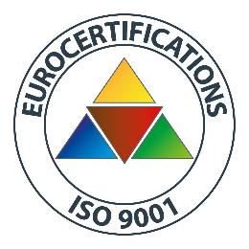
ISO 14001 | 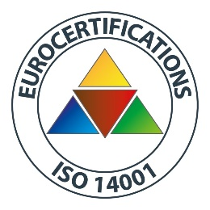
ISO 45001 | 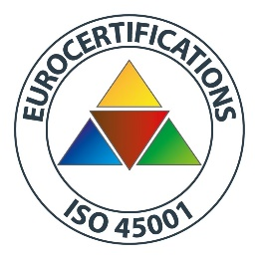
ISO 37001 | 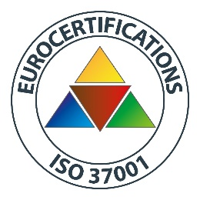
ISO 27001 | 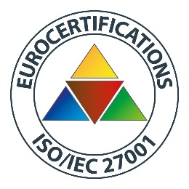
IAF LOGO RED | 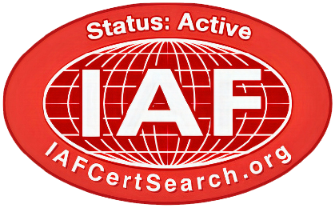

Certification Mark that the Client CANNOT user
IAS LOGO | 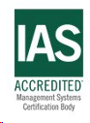
IAF LOGO | 

